**ĐỀ THI TIẾNG ANH Mã đề: 19**

**Trình độ A2**

Họ và tên thí sinh: ……………..……………………………………………………….……………………………………………………………….

Số báo danh: ……………..…………………………………………...……. Phòng thi số: …………………………….…………………

**PAPER TWO LISTENING (Approximately 15 minutes)**

**PART 1: Questions 1 – 5**

*There are five questions in this part. For each question there are three answer choices and a short recording. Tick (***√***) the correct answer. You will hear the piece twice.*

*Example:* ***How many people were at the meeting?***

*A. 3 B. 13* **√** *C. 30*

**1.** What instrument is Edward learning today?

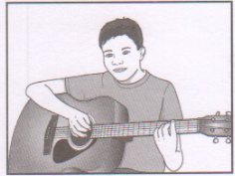 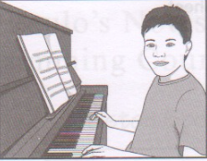 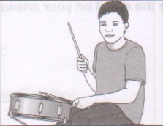

**A** □ **B** □ **C** □

**2.** What will Anna have for breakfast today?

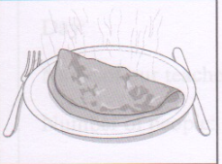 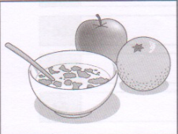 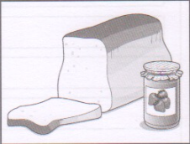

**A** □ **B** □ **C** □

**3.** How much is the watch?

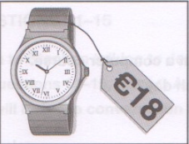 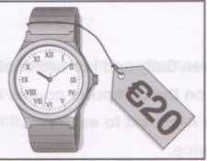 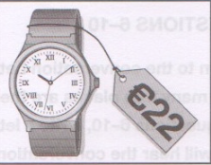

**A** □ **B** □ **C** □

**4.** What does Mandy’s brother do?

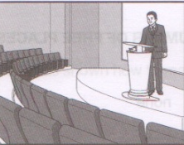 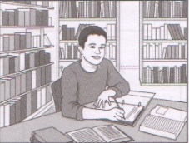 

**A** □ **B** □ **C** □

**5.** Who is coming to stay this weekend?

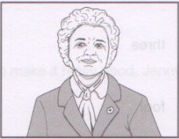 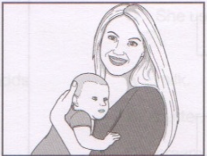 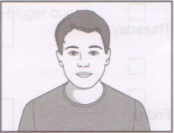

**A** □ **B** □ **C** □

**PART 2:** **Questions 6-10**

*Listen to a conversation between Sally and her father about a computer course. How many free places are there on the computer course each day? For questions 6-10, write a letter A-H next to each person. You will hear the conversation twice.*

|  |  |  |
| --- | --- | --- |
| **EXAMPLE** | **ANSWER** |  |
| **0**  Monday | **D** |  |
| **DAYS** |  | **NUMBER OF FREE PLACES** |
| **6**  Tuesday  **7** Wednesday  **8**  Thursday  **9**  Friday  **10** Saturday |  | **A** none  **B** one  **C** two  **D** three  **E** four  **F** five  **G** six  **H** seven |

**PART 3:** **Questions 11-15**

*Listen to Stephan talking to Jenny about making some soup*

*For questions* ***11-15****, tick (√)* ***A****,* ***B****, or* ***C****. You will hear the conversation twice.*

Example: **0.** To make the soup, Jenny uses

A. roast tomatoes

B. fresh tomatoes

√C. a can of tomatoes

**11.** Jenny was shown how to make the soup by

A. her aunt

B. her friend

C. her mother

**12.** How has Jenny improved the soup?

A. She adds less water

B. She makes it thinner

C. She uses bigger cups

**13.** To make it really good, Jenny adds

A. milk

B. butter

C. cream

**14.** How long does the soup take to make?

A. about 5 minutes

B. about 10 minutes

C. about 20 minutes

**15.** What will they eat next?

A. fruit cake

B. pasta

C. lemon chicken